Chapter 9, Solution 91.

Figure 9.91 shows a parallel combination of an inductance and a resistance. If it is desired to connect a capacitor in series with the parallel combination such that the net impedance is resistive at 10 MHz, what is the required value of C?
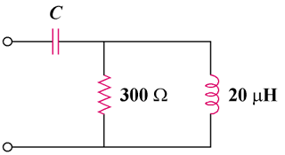

Figure 9.91
For Prob. 9.91.

Solution

To have a resistive impedance, .
Hence,
where

C = 235 pF

